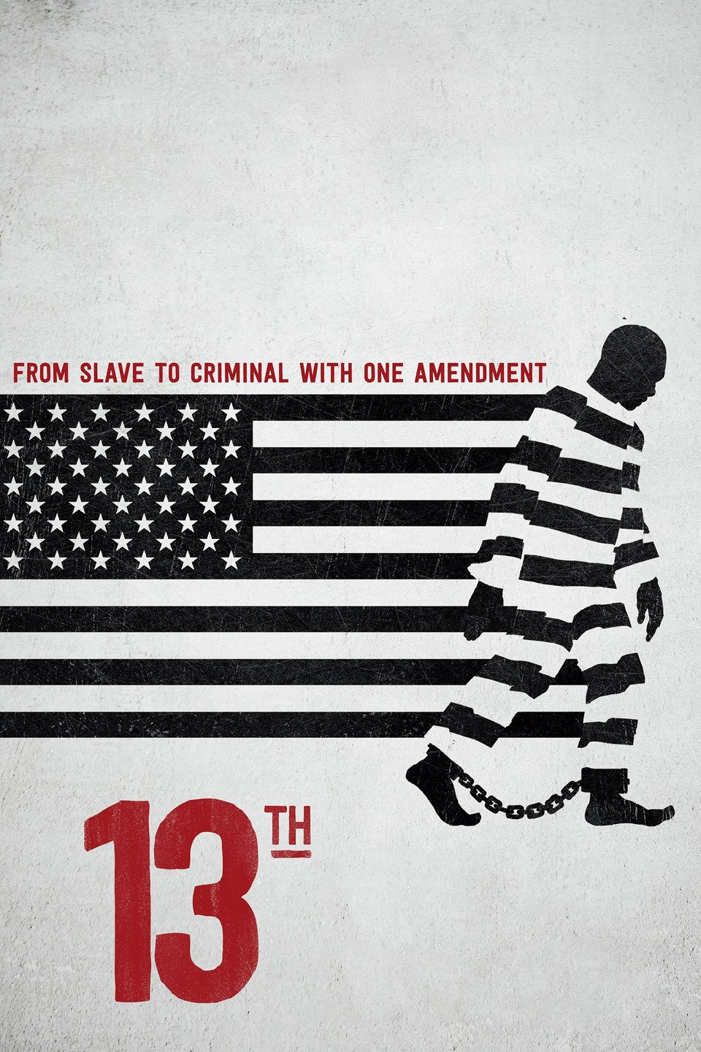
GSR 300: Preserving our Past for the Future: Creating Films for Deaf StoryCorps
Questions for the documentary – 13th Name _________________________________
This film is named for the 13th Amendment in the U.S. Constitution which states -
Section 1. Neither slavery nor involuntary servitude, except as a punishment for crime whereof the party shall have been duly convicted, shall exist within the United States, or any place subject to their jurisdiction.
Section 2. Congress shall have power to enforce this article by appropriate legislation.
The film discusses the Jim Crow laws which were -
state and local laws enforcing racial segregation in the Southern United States. Enacted after the Reconstruction period, these laws continued in force until 1965. They mandated de jure racial segregation in all public facilities in the states of the former Confederate States of America, starting in 1890 with a "separate but equal" status for African Americans. Facilities for African Americans were consistently inferior and underfunded compared to those available to European Americans; sometimes they did not exist at all. This body of law institutionalized a number of economic, educational, and social disadvantages. De jure segregation mainly applied to the Southern states, while Northern segregation was generally de facto—patterns of housing segregation enforced by private covenants, bank lending practices, and job discrimination, including discriminatory labor union practices (this is from Wikipedia).
1. This film is about the 13th Amendment to the U.S. Constitution. Why is the 13th Amendment important? Why are prisoners exempt from the protections in this amendment?

2. How were African Americans, especially males, portrayed in the media (film, news reports, photos, etc.) after the American Civil War (after 1865)?

Over
3. The Civil Rights Act of 1964 - “(Public Law 88–352, 78 Stat. 241, enacted July 2, 1964) is a landmark civil rights and US labor law in the United States that outlaws discrimination based on race, color, religion, sex, or national origin.” The Voting Rights Act of 1965 – “A law passed at the time of the civil rights movement. It eliminated various devices, such as literacy tests, that had traditionally been used to restrict voting by black people.” How do these laws help African-Americans in the U.S.?

4. Mass incarceration started in the 1970s. What are two reasons why the population in American prisons has increased from the 1970s to today?
A.

B.

5. Thirty-eight people are interviewed in this film. Look at the interviews. How are these interviews different from ones you have seen in other films? (Look at how the people are sitting and where the cameras are.)

6. ALEC is the American Legislative Exchange Council. “The American Legislative Exchange Council is America’s largest nonpartisan, voluntary membership organization of state legislators dedicated to the principles of limited government, free markets and federalism” (from the www.ALEC.org website). What has this organization done related to laws in the U.S.? (What laws has it helped push through state legislatures?

7. How are corporations (businesses) profiting from American prisons/prisoners?

8. What parallels can you make related to issues of social justice/injustice in today’s society?

Think about the ideas you see in this film. What are two important themes in this film? Why do you think these themes are important?
9.

10.

Reflect and write on these questions
- What did you learn about how Frost’s interviews with Nixon?

- How effective were the interviews?

- Did Frost accomplish what he wanted to accomplish during the interviews?

- If you had been Frost, what questions would you have asked or what would you have done differently?

